**Case study – ELB,ASG AND ROUTE 53**

**Problem Statement: You work for XYZ Corporation that uses on premise solutions and a limited number of systems. With the increase in requests in their application, the load also increases. So, to handle the load the corporation has to buy more systems almost on a regular basis. Realizing the need to cut down the expenses on systems, they decided to move their infrastructure to AWS**

**Tasks To Be Performed:**

**1. Manage the scaling requirements of the company by:**

**a. Deploying multiple compute resources on the cloud as soon as the load increases and the CPU utilization exceeds 80%**

**b. Removing the resources when the CPU utilization goes under 60%**

**2. Create a load balancer to distribute the load between compute resources.**

**3. Route the traffic to the company**

Tasks To Be Performed:

1. Manage the scaling requirements of the company by:

a. Deploying multiple compute resources on the cloud as soon as the load increases and the CPU utilization exceeds 80%

Create 2 EC2 Instance

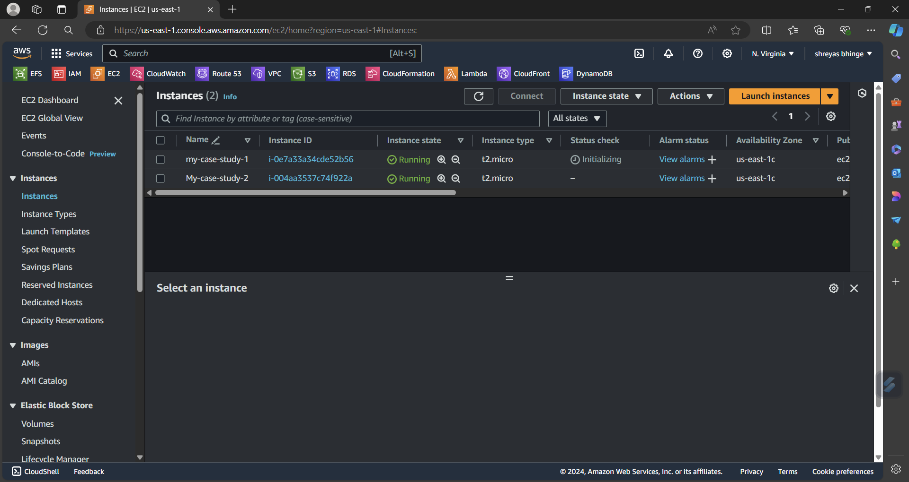

* In first instance

I Installed nginx

By using below command

Sudo su sudo apt-get update

Sudo apt install ngnix

Sudo systemctl start nginx

Sudo systemctl status nginx

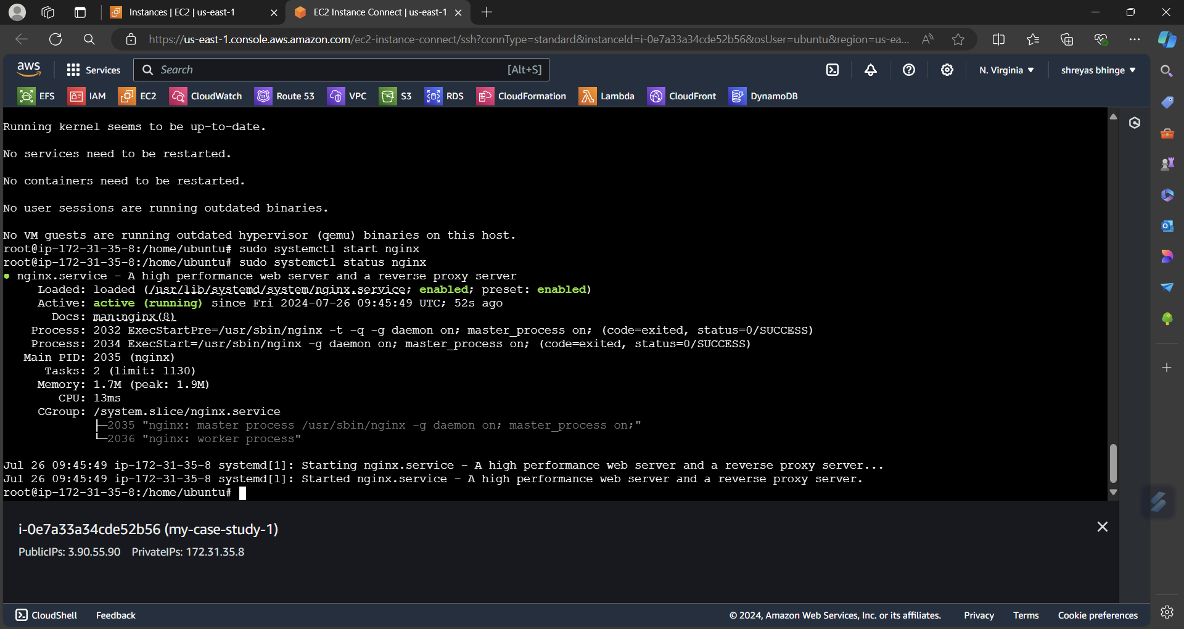

* You will find this page

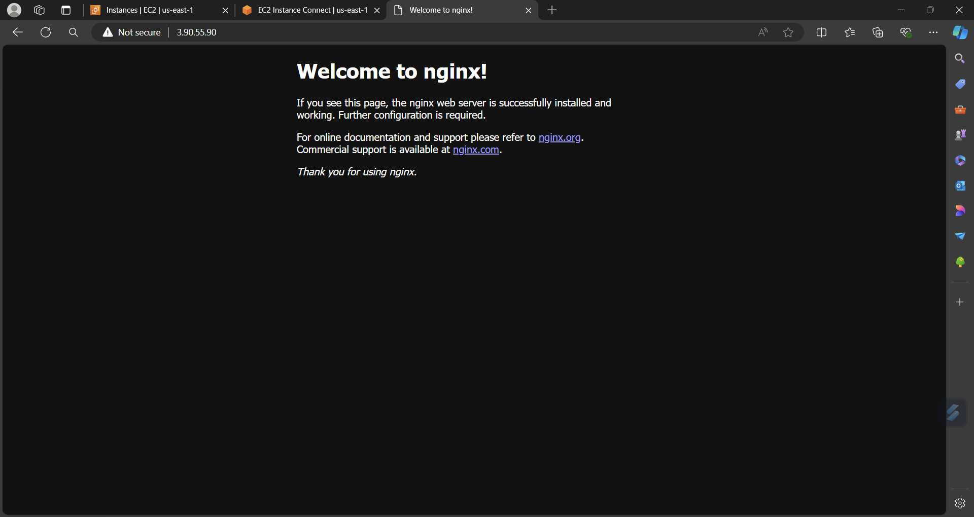

In the same way create 2nd instance

Sudo apt-get update

Sudo apt install apache2

Sudo systemctl start apache2

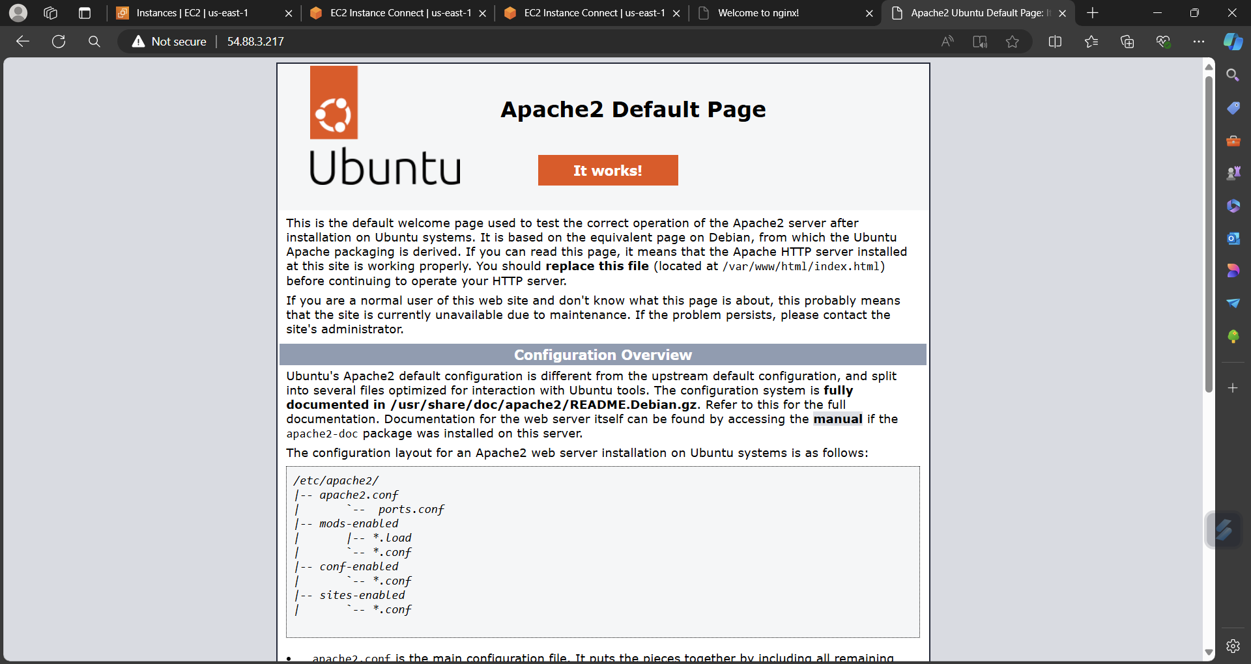

* Now Create target group

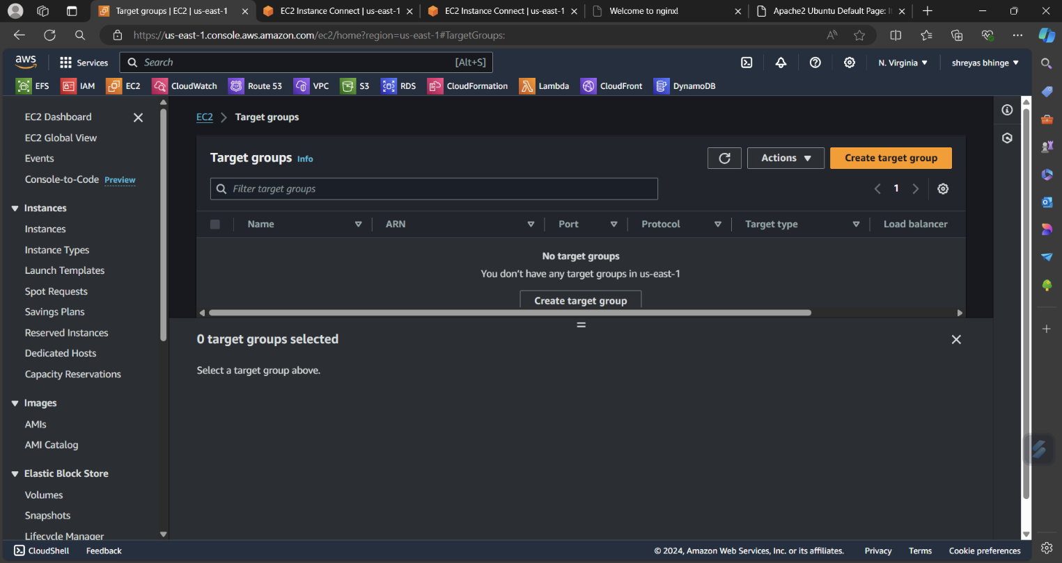

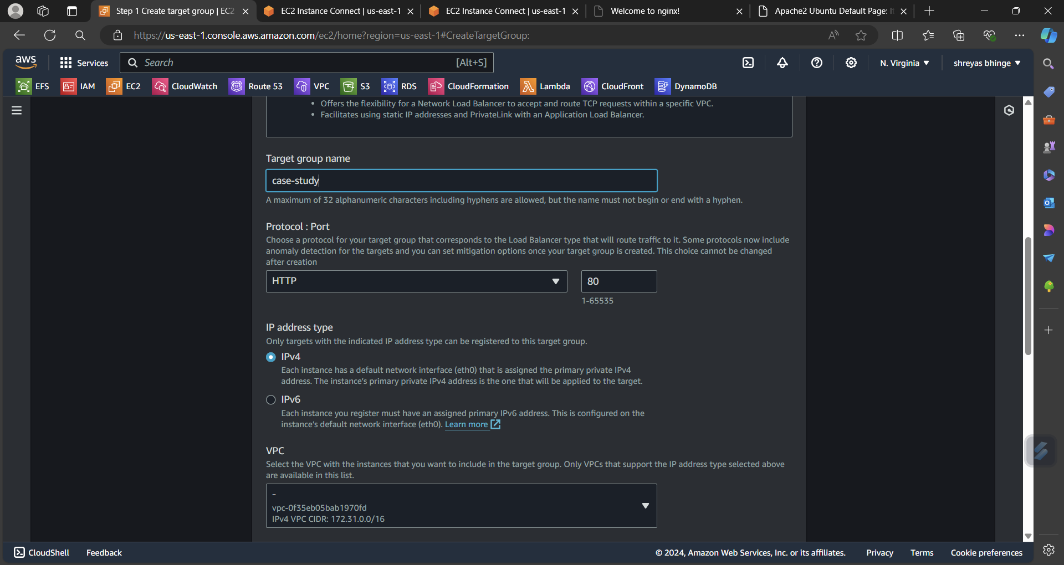

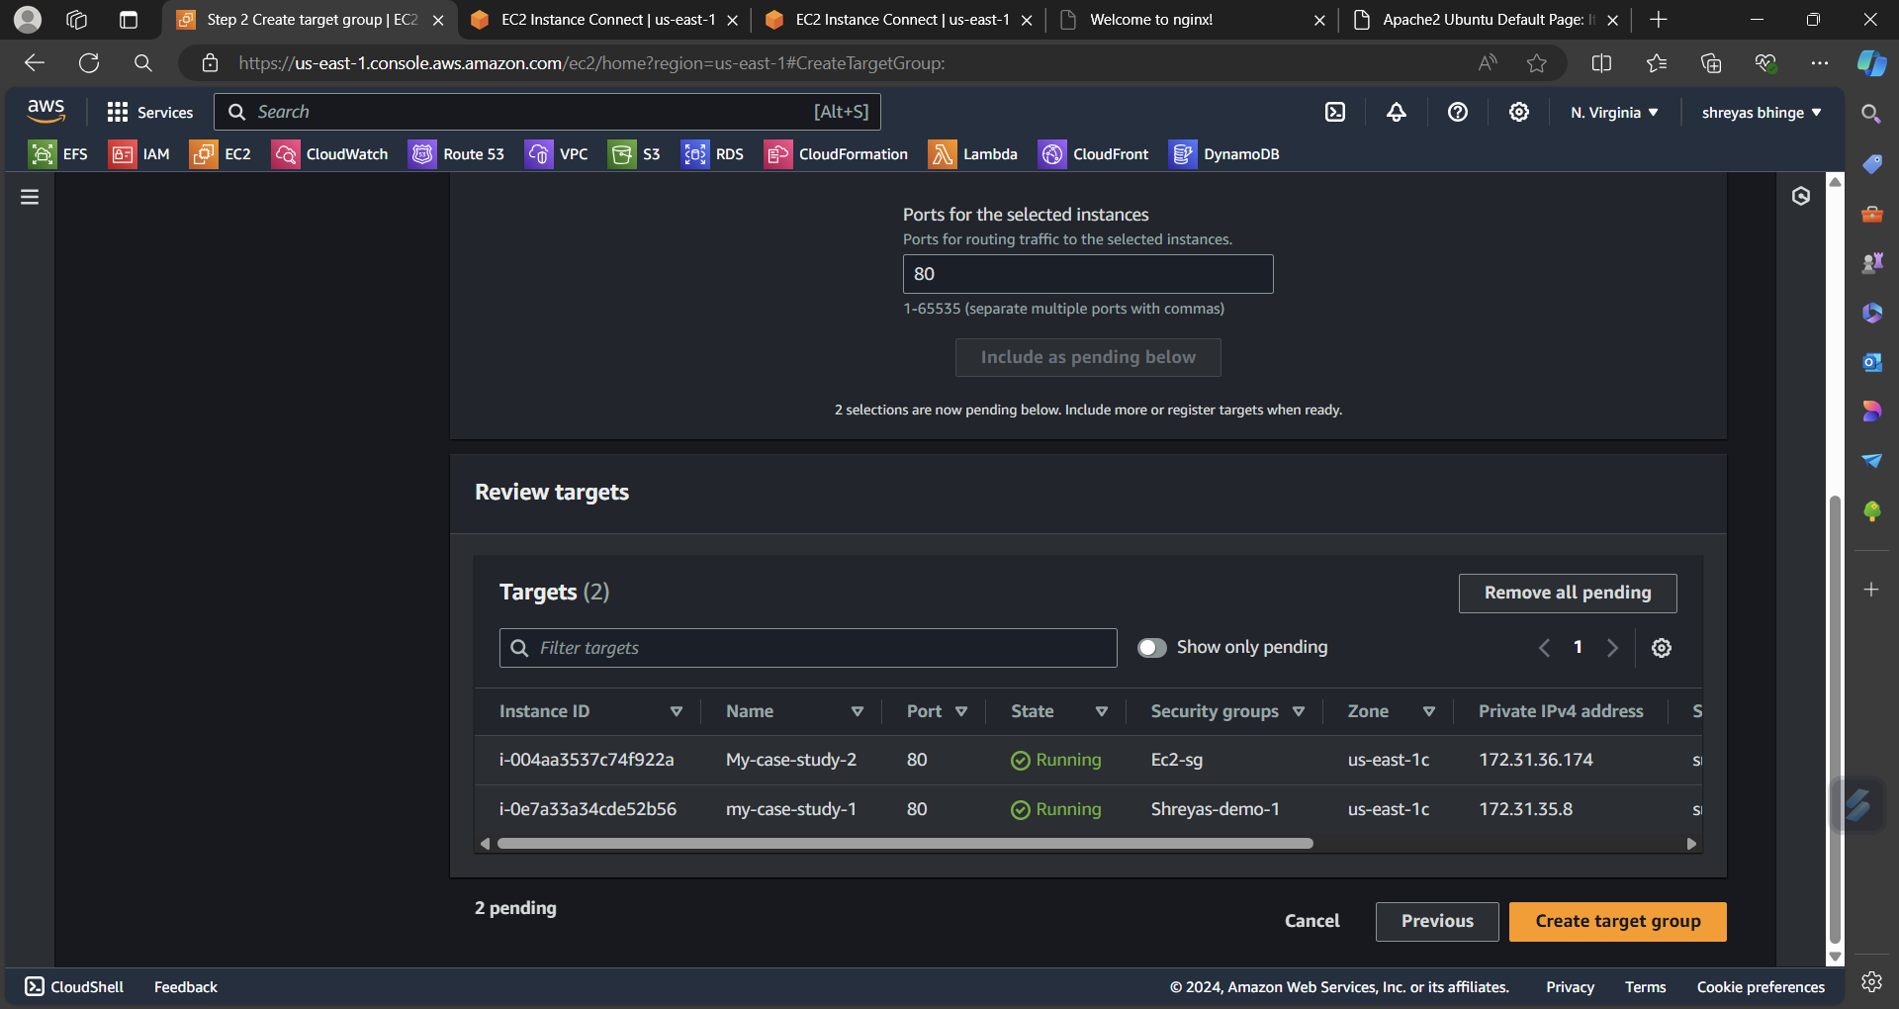

* Now launch template

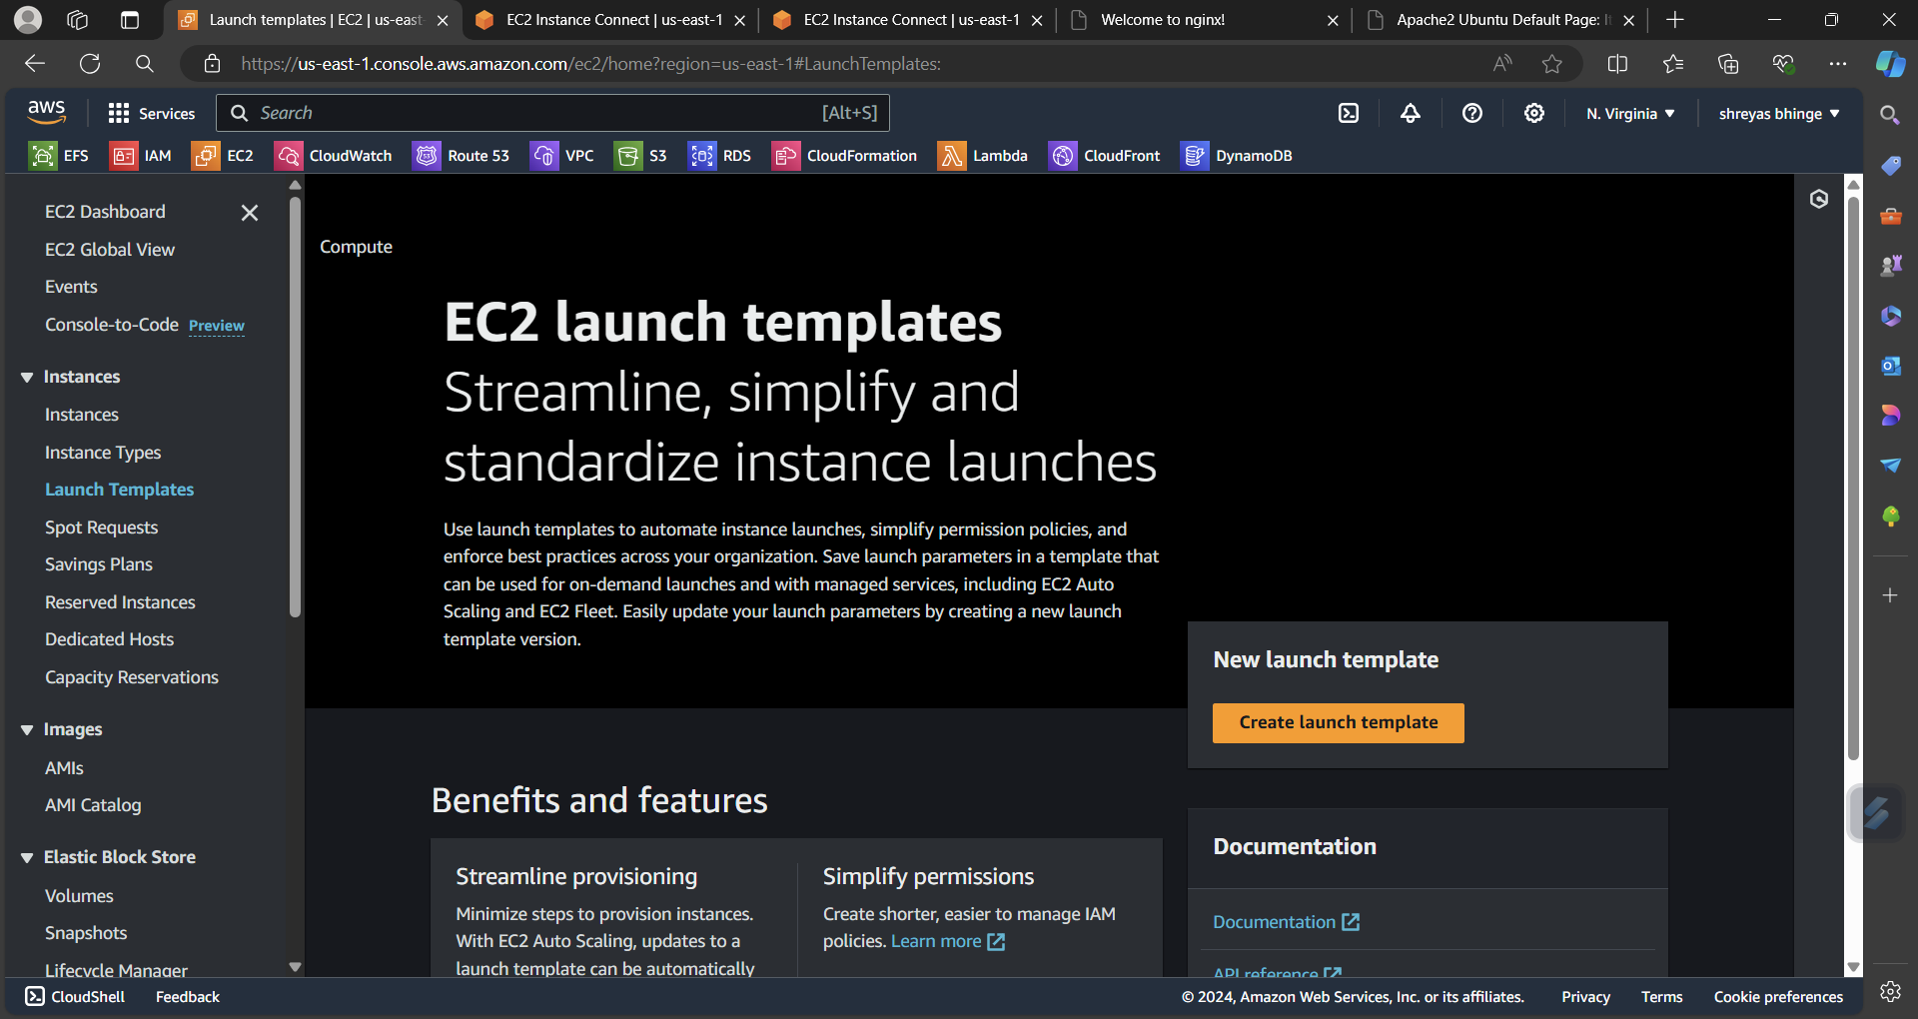

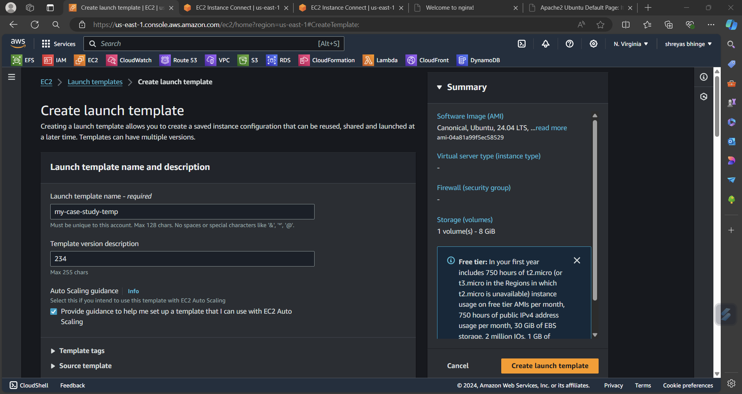

* Now launch Auto scaling

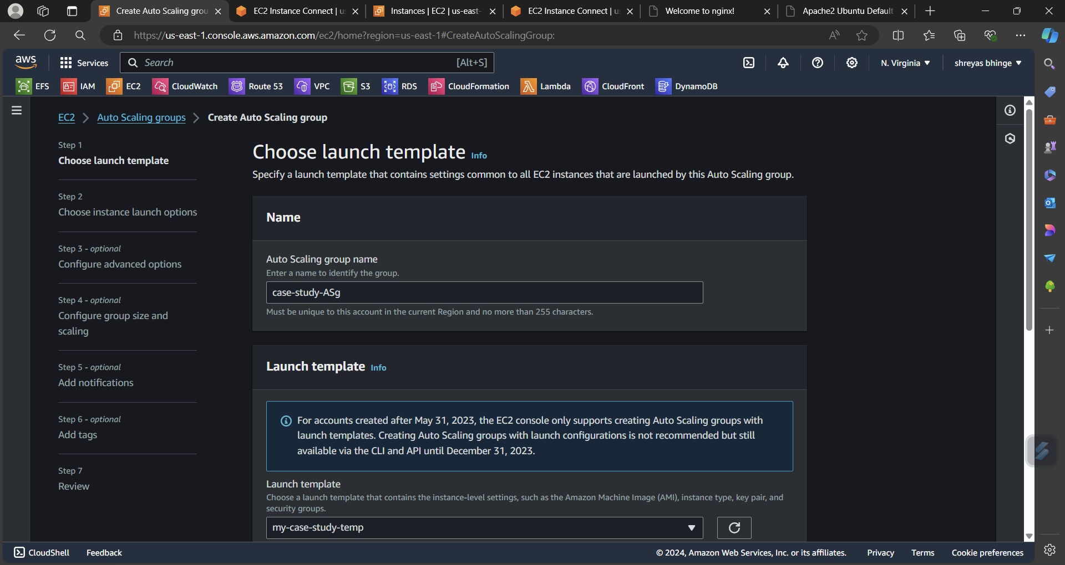

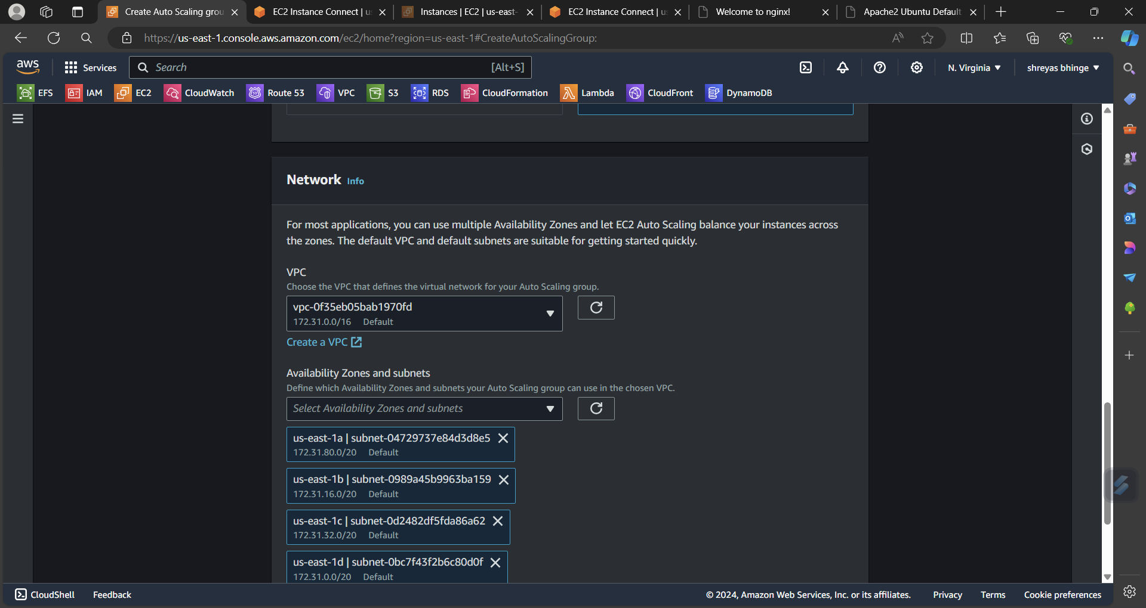

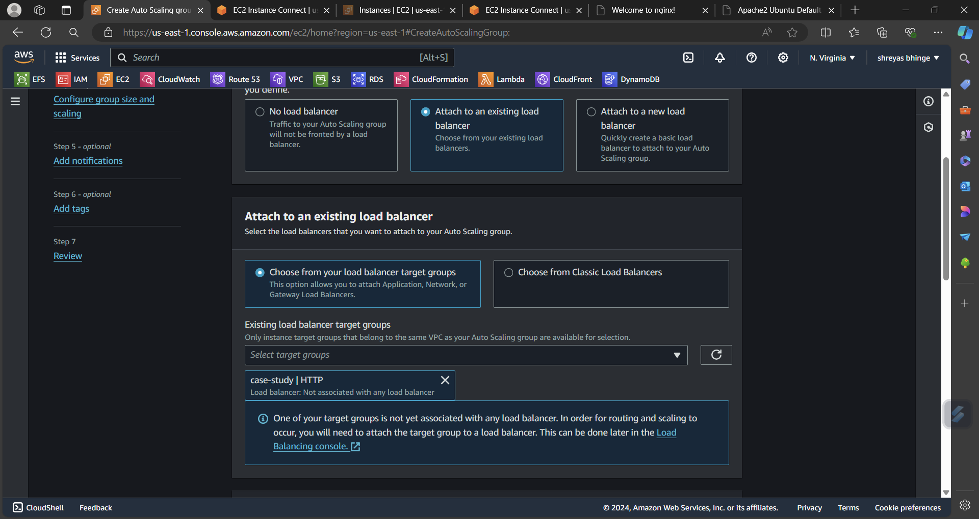

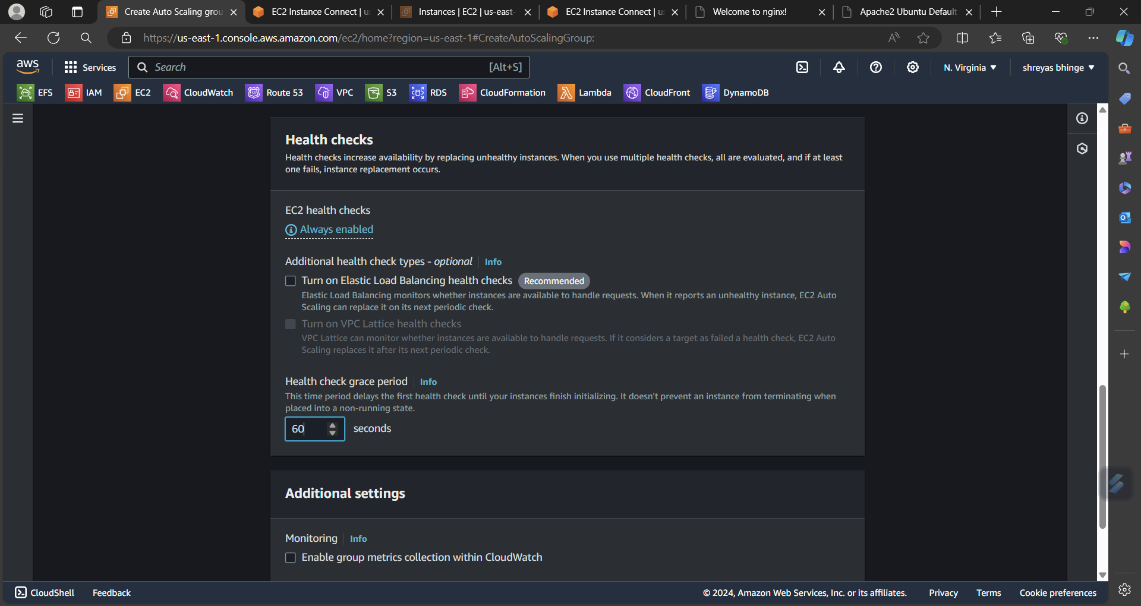

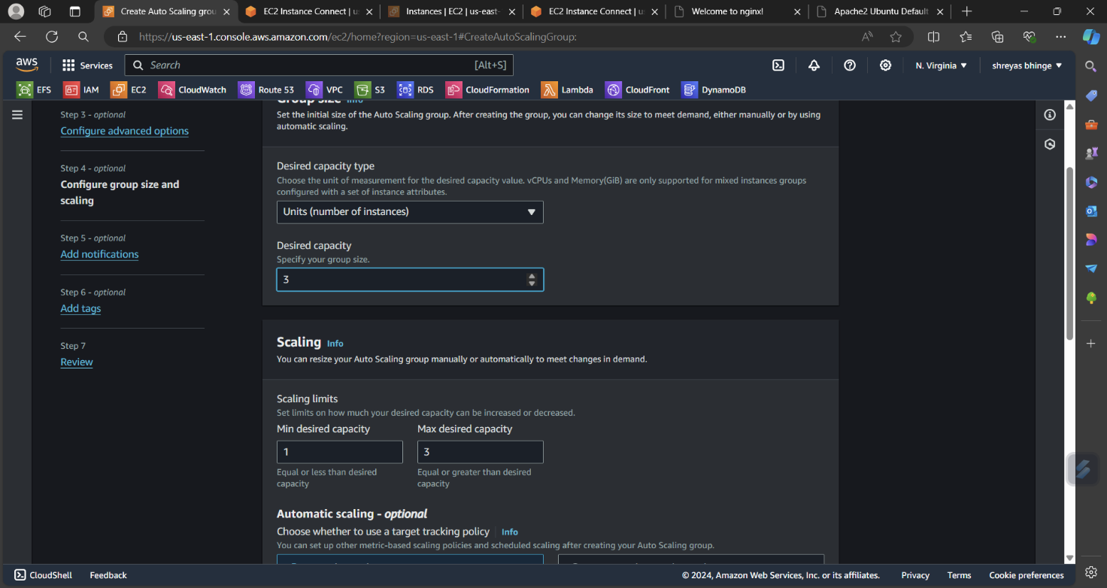

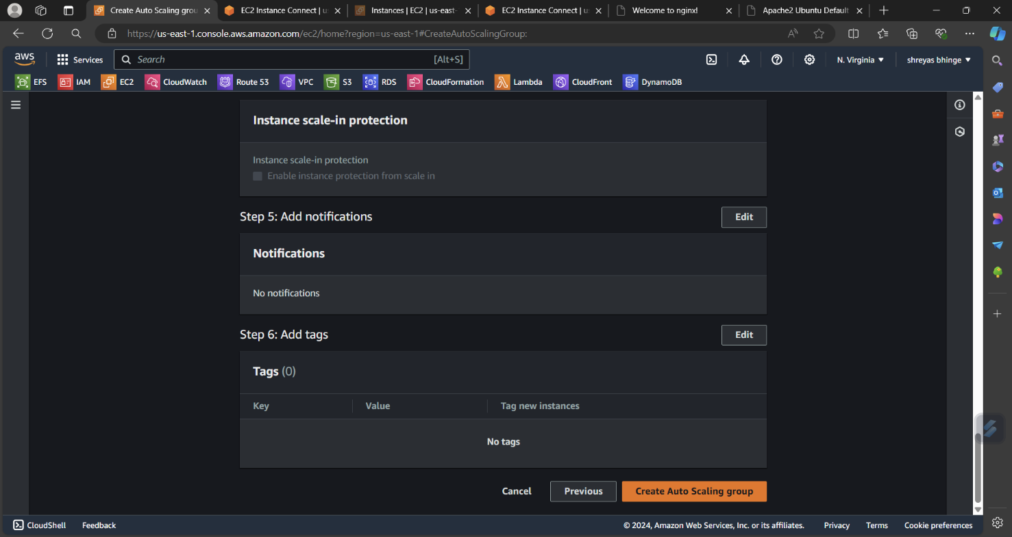

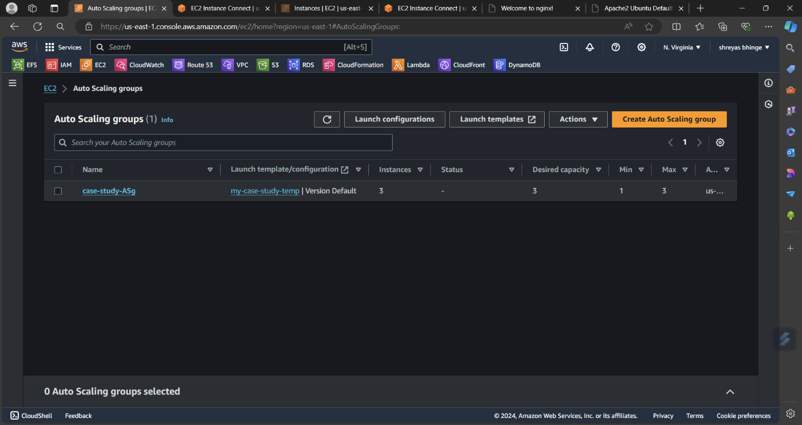

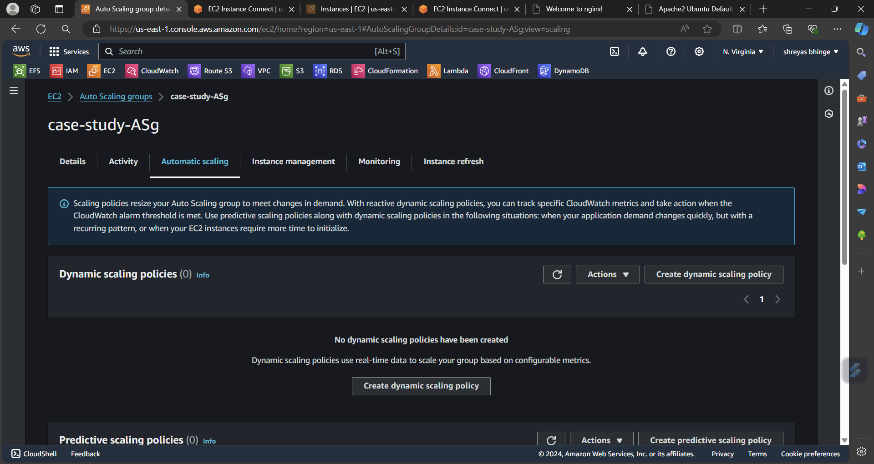

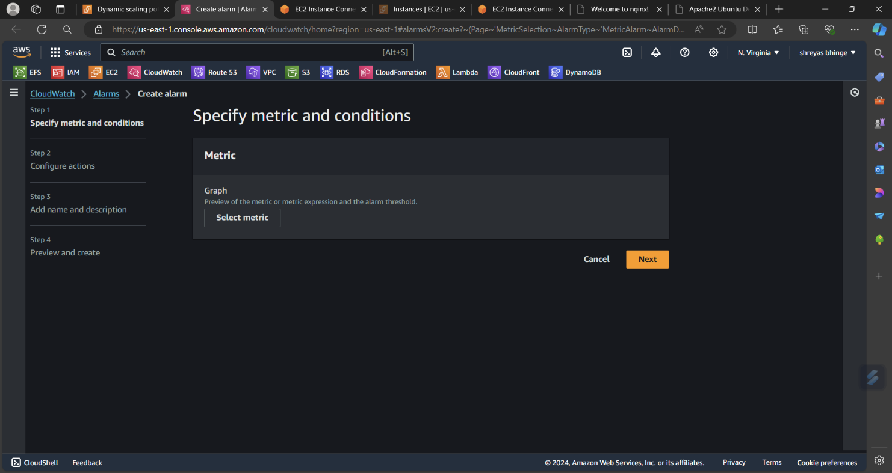

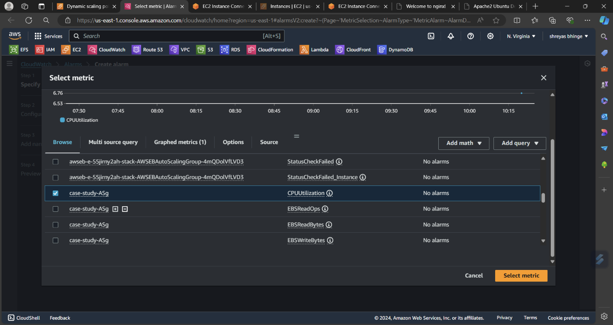

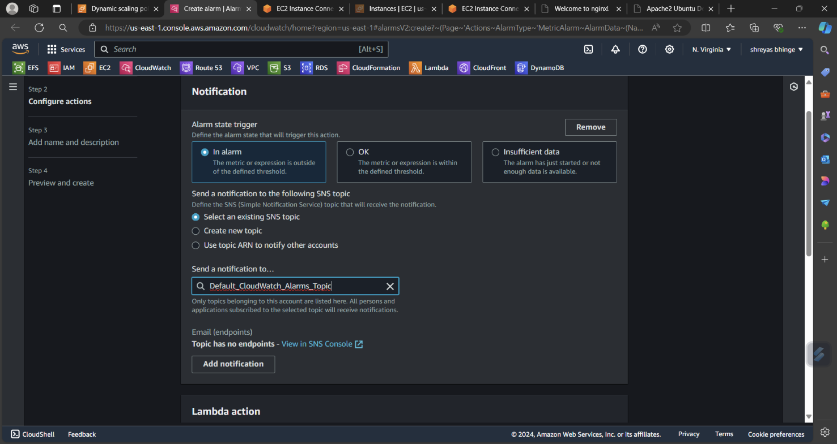

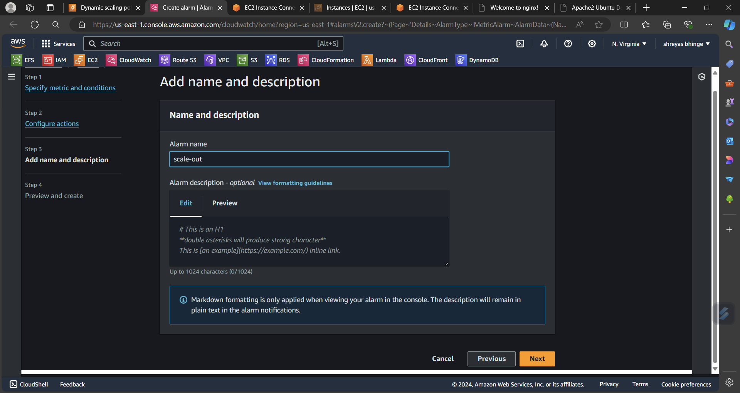

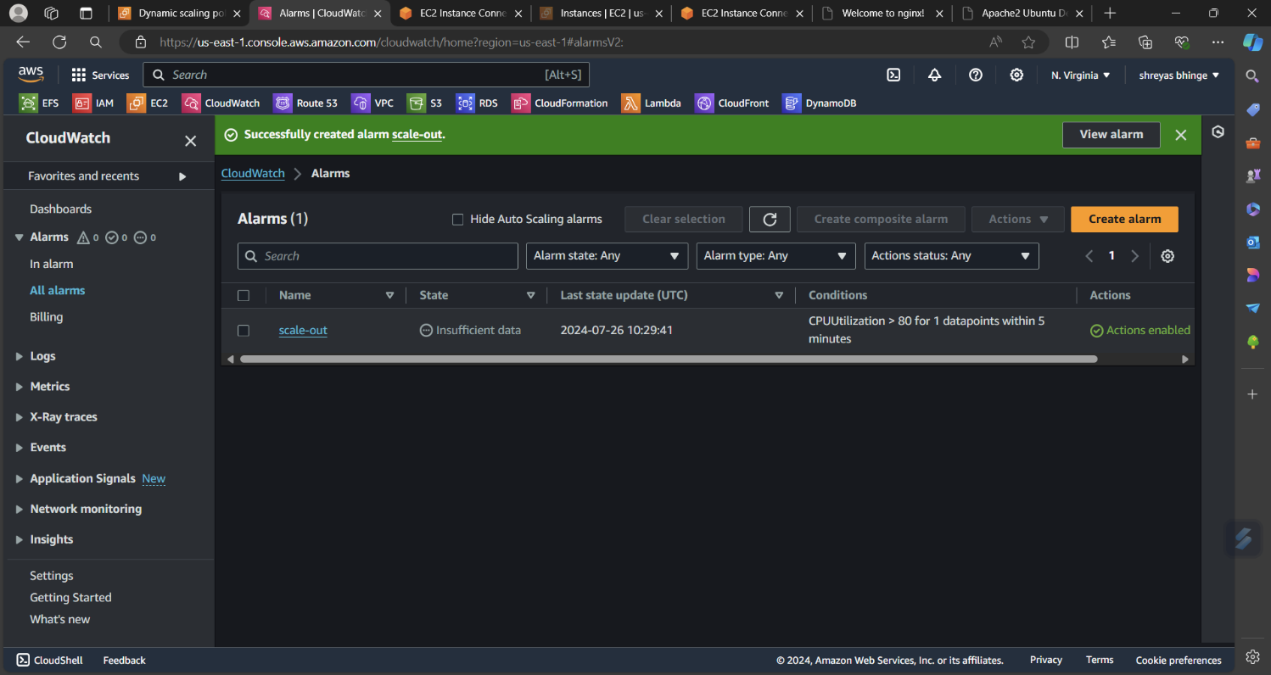

**b. Removing the resources when the CPU utilization goes under 60%**

Follow the same steps from dynamic scaling for scale in

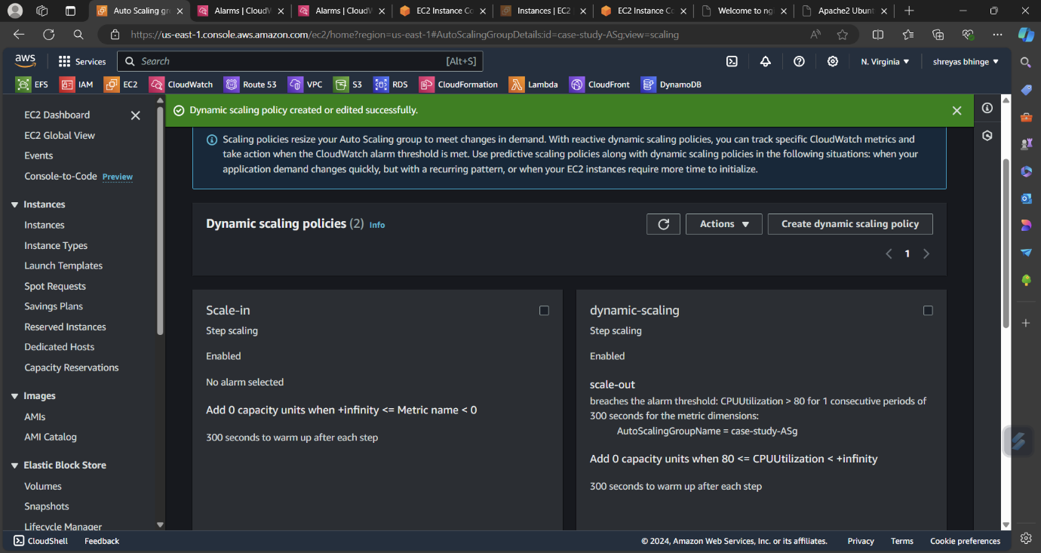

2.Create a load balancer to distribute the load between the compute resource

* Create a load balancer (Application L.B)

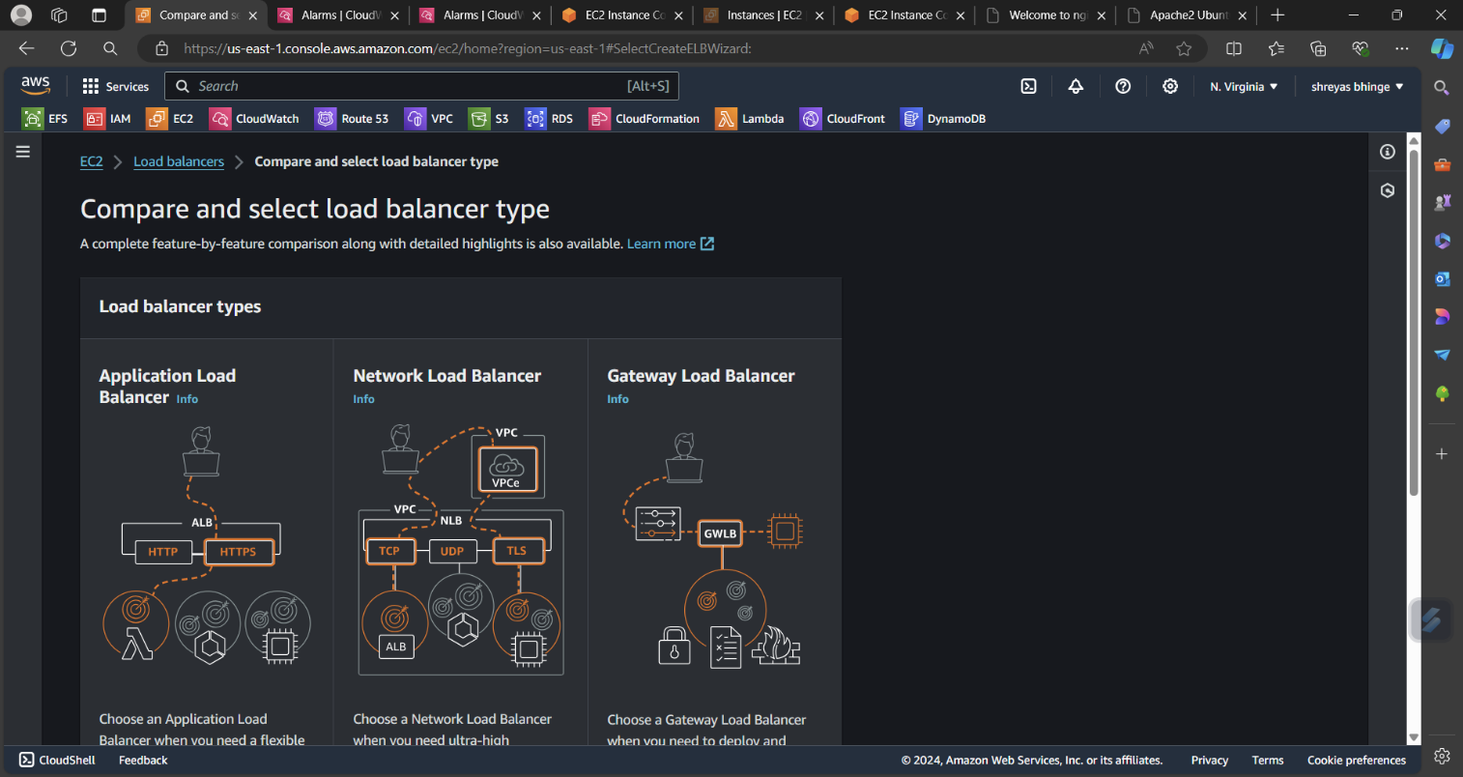

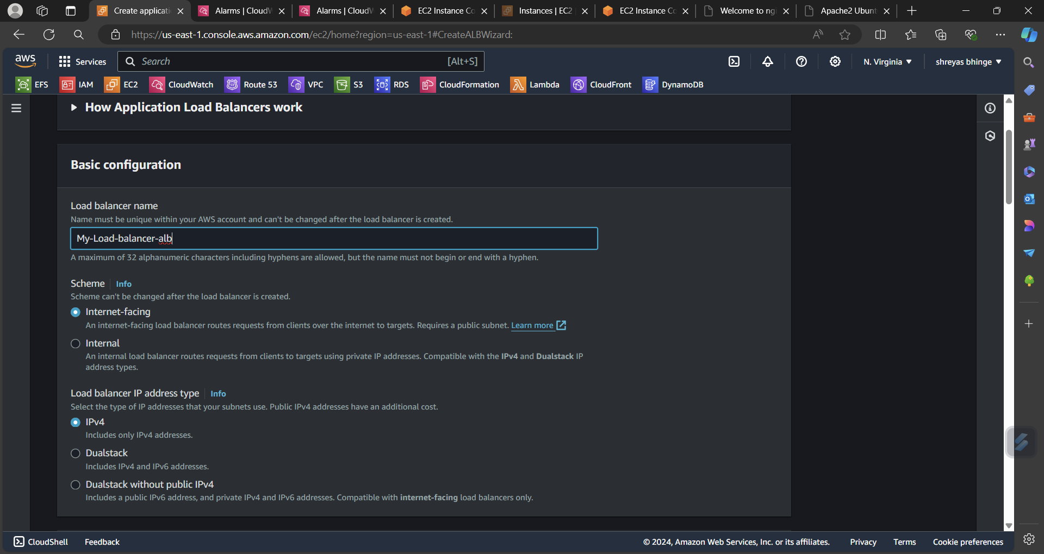

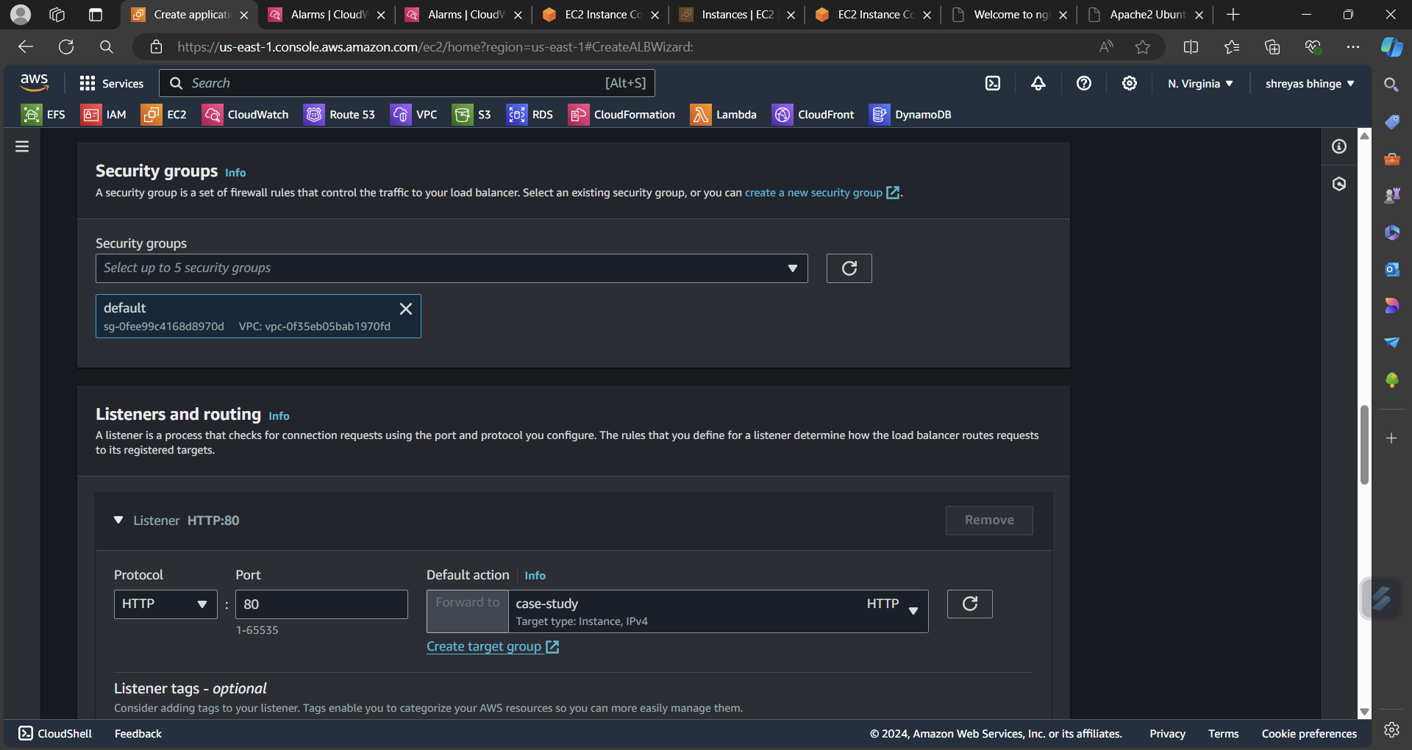

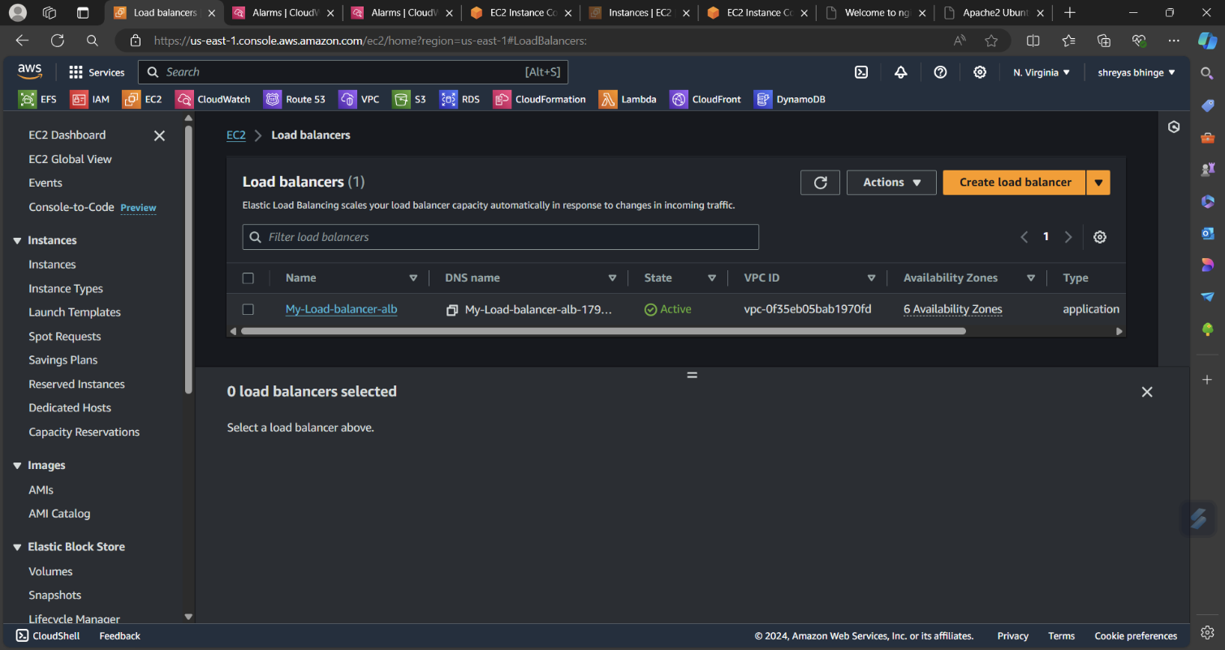

3. Route traffic to the company

Now go to route 53

Select hosted zone

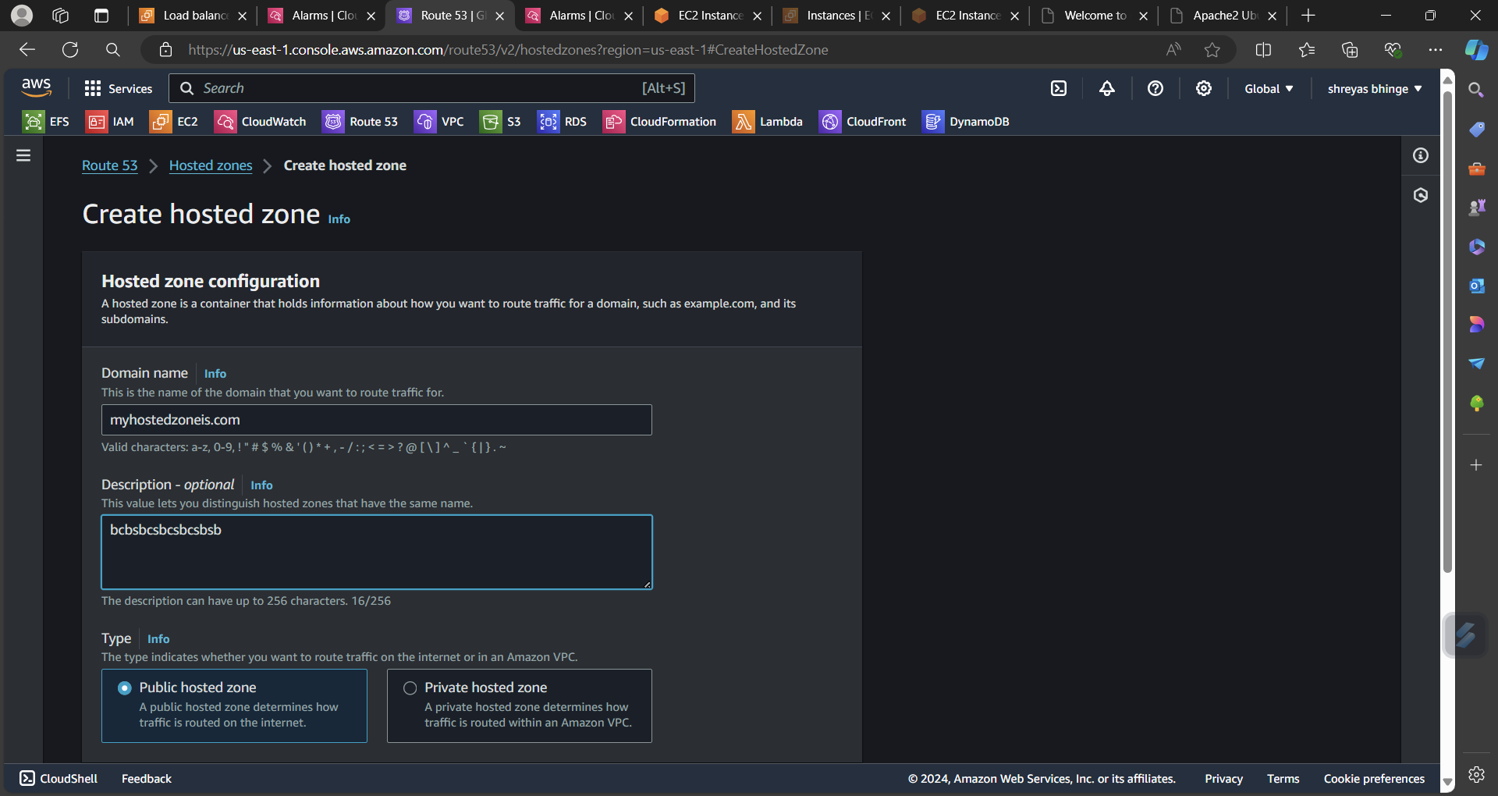

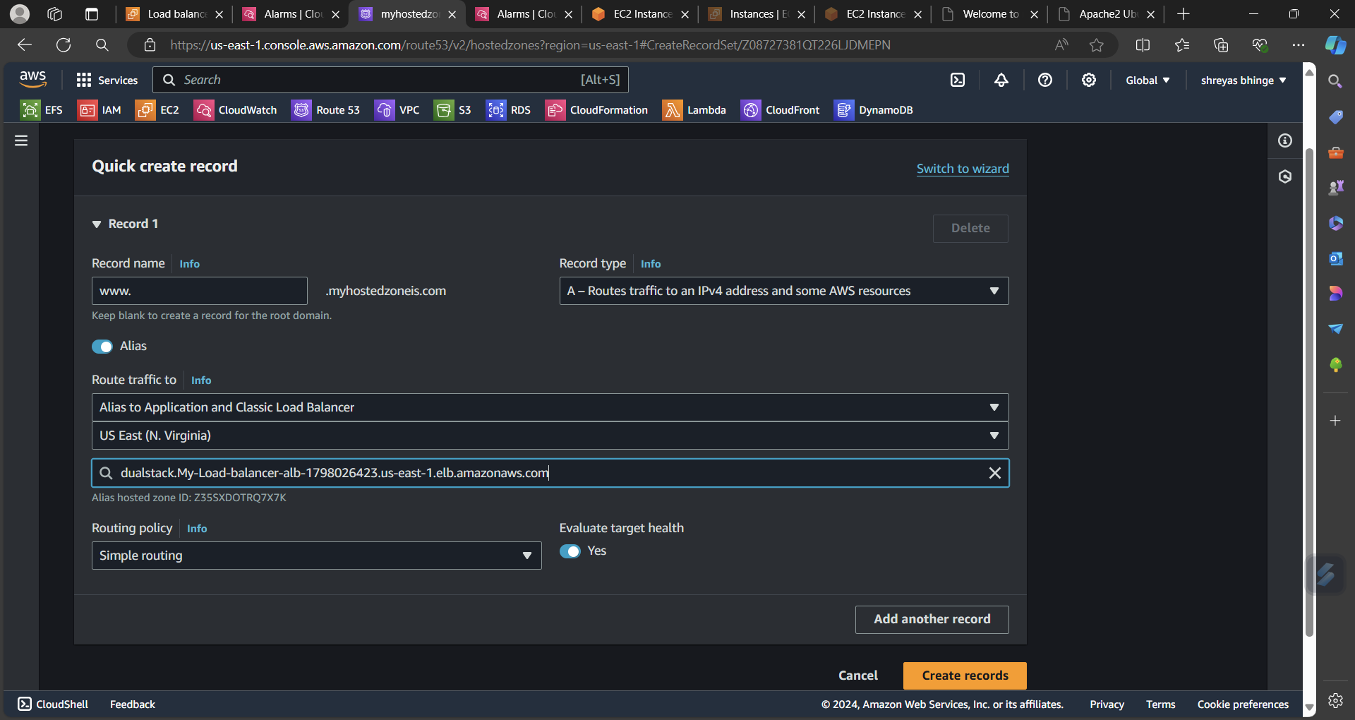

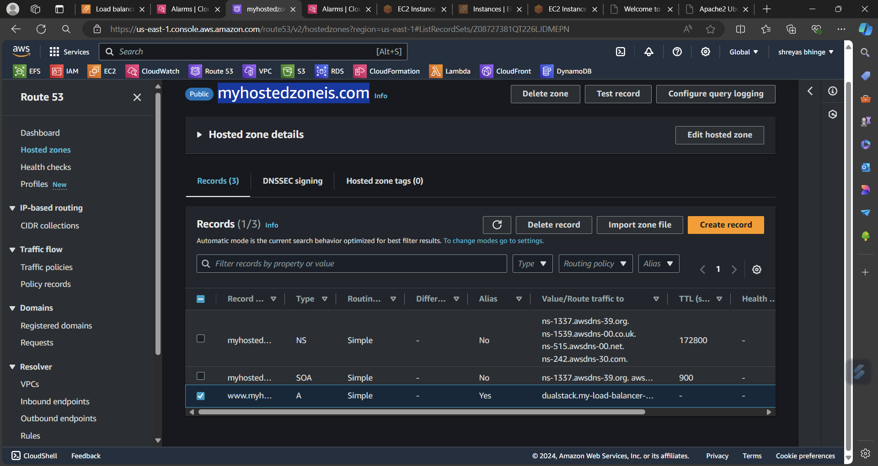

* Hit the Domain after few hours